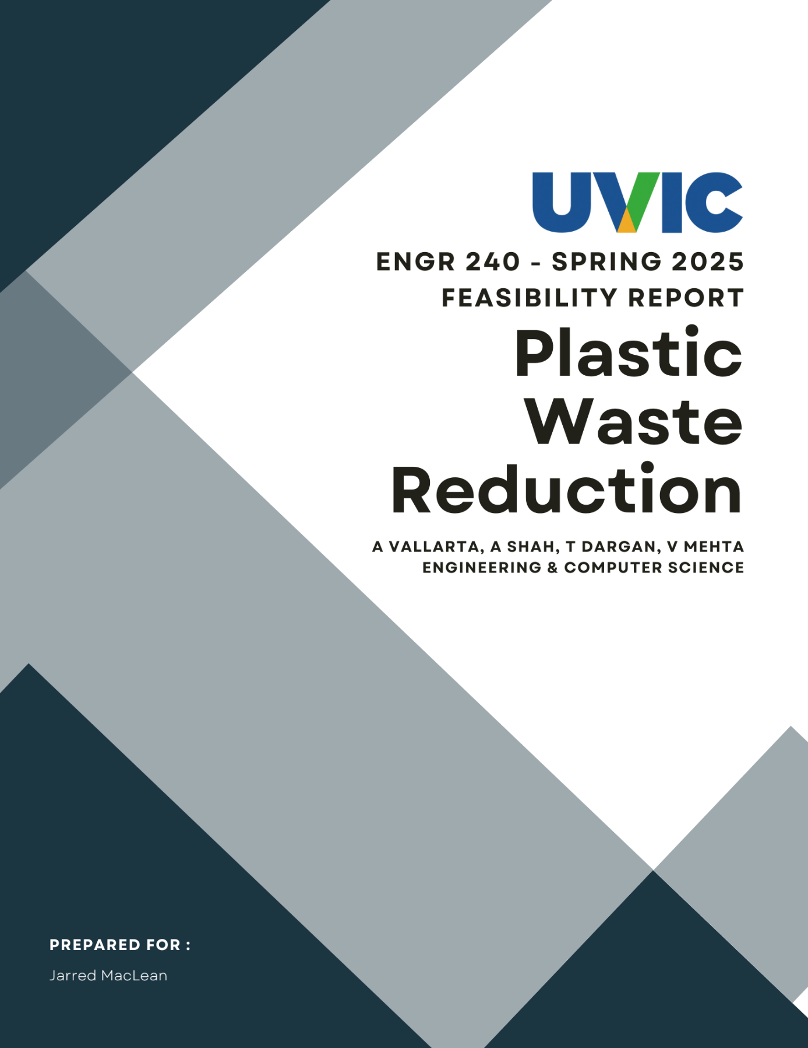

**Table of Contents**

**1. Introduction 5**

1.1. Topic & Purpose 5

1.2. Client Background 5

**2. Problem Definition 6**

2.1. Need Statement 6

2.2. Goal Statement 6

2.3. Objectives 6

2.4. Constraints 7

2.5. Benefits 7

**3. Proposed Design Solution 8**

**4. Methods of Investigation 10**

4.1. Research Purpose 10

4.2. Survey Development 10

4.3. Client Feedback Collection 11

4.4. Online Research 11

4.5. Data Collection 12

4.6. Guideline Considerations 12

**5. Results 13**

5.1. Survey Results 13

5.2. Online Research Findings 17

5.3. Client Feedback 18

**6. Discussion 20**

6.1. Survey Results Discussion 20

6.2. Waste Generation and Sorting Challenges 20

6.3. Feasibility and Implementation Considerations 21

**7. Recommendation 22**

**8. Conclusion 24**

**9. References 25**

**10. Appendices 27**

**List of Tables and Figures**

* **Figure No. 1 - Distribution of respondents who do not live on campus.**
* **Figure No. 2 - Distribution of respondent’s average time spent on campus.**
* **Figure No. 3 - Distribution of respondents who sort their trash.**
* **Figure No. 4 - Respondent’s perceived level of difficulty in sorting trash rated out of five.**
* **Figure No. 5 - Distribution of Respondents on how likely they would properly sort their trash if automatic sorting is implemented rated out of five.**
* **Figure No. 6 - Respondents’ Support for Automatic Trash Sorting on Campus.**
* **Table 1 - Cost Analysis**

**Executive Summary**

This report examines the implementation of an AI-powered waste sorting system to improve waste management at the University of Victoria. Specifically, it proposes integrating an image recognition algorithm into the existing "Sort It Out" bins to increase landfill diversion rates and reduce operational inefficiencies. Since improper waste sorting contributes significantly to landfill waste [1], even a moderate improvement in sorting accuracy would lead to substantial environmental benefits.

To investigate this topic, we conducted an online review of AI-based waste sorting technologies [2], analyzed previous studies on automated waste management [1], and gathered insights from campus stakeholders. Our research identified the ESP32-CAM module combined with a convolutional neural network (CNN) as the optimal solution for real-time waste classification [3]. We estimate that, after a period of calibration and user adaptation, the system could reduce manual sorting efforts by 50% and improve recycling efficiency [2].

Given the potential impact of this technology and the relatively low implementation risk, this report strongly recommends the development and deployment of the AI-enhanced waste sorting system on campus. The following sections detail the methodology, results, and recommendations for refining and expanding this initiative.

## Introduction

### Topic & Purpose

This report evaluates the feasibility of implementing camera-assisted automated waste sorting bins at the University of Victoria. By integrating a microcontroller and motors with the existing waste management infrastructure, the system will accurately classify and direct waste into the appropriate compartments, thereby improving recycling efficiency and reducing the manual sorting workload for waste management staff.

### Client Background

The University of Victoria (UVic) is widely recognized for its leadership in sustainability, ranking second in Canada and fourth globally for advancing sustainable urban development [9]. Between 2009 and 2018, the university successfully improved its landfill diversion rate from 58% to 74% through extensive recycling and composting programs [9]. However, reaching the 81% target set in UVic’s latest Strategic Plan requires further innovative approaches to tackle the issue of plastic waste and improper sorting, which currently contribute to 18% of landfill disposal [9]. With the scheduled closure of Hartland Landfill in 2040, UVic faces increasing pressure to optimize its waste management strategies to mitigate both environmental and financial impacts [9]. Collaborating with local organizations and government agencies could provide valuable insights and resources to help achieve these sustainability goals. Additionally, offering more incentives for students and staff, such as discounts at campus dining facilities for using reusable containers, could further reduce the reliance on single-use plastics [9].

## Problem Definition

We explore the problem definition through the following sections:

### Need Statement

Current waste management systems lack an efficient method for automatically identifying and sorting waste materials. As a result, workers must manually sift through mixed waste, leading to delays, increased labor costs, and a higher risk of exposure to hazardous materials. This inefficiency contributes to improper waste segregation, reducing recycling effectiveness and increasing landfill waste. The absence of accurate and automated sorting also exacerbates environmental pollution, resource depletion, and greenhouse gas emissions from mismanaged waste.

### Goal Statement

Improve waste sorting accuracy at the University of Victoria to achieve landfill diversion rate of at least 81% and enhance recycling efficiency, minimizing environmental impact and operational strain on waste management staff.

### Objectives

An effective solution should ideally be able to achieve the following outcomes:

* Simplify and improve the efficiency of waste segregation at the source.
* Reduce manual sorting labor for campus waste management staff.
* Increase the recycling rate of plastics, metals, and other recyclable materials.
* Contribute to UVic’s 81% landfill diversion rate target.
* Provide a scalable model for future waste management technologies.

### Constraints

The proposed project must adhere to the following constraints:

* A maximum budget of $100,000.
* A two-year timeline for implementation.
* Compliance with UVic’s safety and environmental regulations.
* Seamless integration with existing bins and campus infrastructure.

### Benefits

Conducting this investigation into the feasibility of an AI-powered waste sorting system offers several key benefits:

* **Data-Driven Decision-Making:** Provides UVic with concrete evidence on whether an AI-based waste sorting system is a viable and effective solution.
* **Resource Allocation Efficiency:** Helps determine if investing in automated waste sorting is justified, preventing unnecessary expenditures on ineffective solutions.
* **Identification of Challenges:** Highlights potential technical, logistical, and financial barriers before committing to full-scale implementation.
* **Stakeholder Insights:** Gathers feedback from waste management staff and campus users to assess practical considerations and acceptance of the proposed system.
* **Contribution to Sustainability Research:** Adds to the body of knowledge on AI-assisted waste sorting, which can inform future sustainability initiatives at UVic and beyond.

## Proposed Design Solution

The proposed design solution this report investigated is the development of a single-point waste sorting system that integrates seamlessly with the existing "Sort It Out" bins on campus. This solution provides a convenient and automated method for ensuring proper waste segregation, reducing the risk of missorting and promoting sustainable waste management practices.

The system would feature a single deposit point where users can discard waste items. Upon disposal, a built-in ESP32-CAM (Espressif System on a Chip 32-bit with Camera) module captures an image of the item and uses advanced image recognition technology to determine the type of trash—such as recyclable, compostable, or general waste. Once identified, the system activates a motorized pulley system that redirects the item to the appropriate bin compartment, ensuring accurate sorting and preventing cross-contamination between waste streams.

To improve user interaction, the system could incorporate a simple feedback mechanism, such as an LED indicator or screen, to notify users of the identified waste type and the sorting action performed. Strategically placing these upgraded bins in high-traffic campus areas—such as libraries, dining halls, and student unions—would ensure accessibility and encourage widespread use. Regular maintenance, including cleaning and calibration, would be essential to maintain operational efficiency and user trust.

This automated design eliminates the need for manual sorting, reducing human error and making waste disposal more efficient and intuitive. Additionally, incentive programs, such as sustainability rewards or educational campaigns, could be introduced to further engage the campus community and promote environmentally responsible behavior.

If successfully implemented, this design solution has the potential to significantly improve waste management practices on campus. By preventing missorting and fostering a culture of sustainability, the system aligns with the university’s environmental goals while enhancing awareness about proper waste disposal among students and staff.

## 

## Methods of Investigation

The report uses an analytical approach, divided into phases to assess the feasibility of an automated waste sorting system, including defining research objectives, conducting a survey, gathering client feedback, and researching costs and technical solutions.

### Research Purpose

This study employs a quantitative research approach using a survey, client feedback, and financial research to assess the viability of an automatic sorting system. Moreover, the project evaluates technical design, user acceptance, and cost to determine whether a campus-wide implementation is feasible and practical.

* **Key Feasibility Factors:** Determining the economic, technical, and operational viability of the proposed solution.
* **Student Need and Interest:** Understanding the frequency of waste generation and the willingness to adopt new waste management technologies.
* **Environmental Impact:** Evaluating alignment with the university’s environmental innovation goals.

### Survey Development

A structured questionnaire was developed to collect quantitative and qualitative insights. The questions were designed to assess the following aspects:

* **Student Need:** Frequency of student activity and waste generated on campus.
* **Student Interest:** How willing would a student be with a new trash system instead of the current implementation.
* **Environmental Impact:** If the system will align with Uvic’s commitment to environmental innovation and protection.

The survey questions were designed to collect direct feedback on the system’s feasibility and functionality. This approach ensures that user adoption and perceived usefulness are evaluated before implementation.

### Client Feedback Collection

Feedback from the university’s waste management division served to clarify existing pain points and institutional requirements:

* Feedback was gathered during the client’s initial presentation and through progress reports in class.
* Key topics included waste management needs, preferences, and potential obstacles to implementation.
* Specific points were raised about the potential for a single, centralized sorting facility, focusing on high-volume areas where the system would have the greatest impact.

These insights helped refine the system requirements to ensure the automated bins would address the practical concerns of campus waste management.

### Online Research

**Financial Feasibility** Cost estimates derived from component prices available on Digikey Canada [10]. Anticipating costs for initial setup, including hardware, installation, and potential maintenance.

**Technical and AI Feasibility**

Research on AI image sorting methods, referencing study papers [1] and [2]. Exploration of thermal imaging, object detection, and sensors to determine whether containers contain liquids or food residue before sorting. Consideration of complex waste types (e.g., empty versus non-empty containers, food waste in other waste streams). This information was used to validate the design choices and identify the potential return on investment for a campus-wide rollout.

### Data Collection

The structured survey was administered via SurveyMonkey over 10 days:

* Anonymity was guaranteed to encourage honest, unbiased responses.
* 10 total responses were collected, providing initial quantitative data on student needs, preferences, and interest in automated sorting.

In parallel, client feedback and online research data were integrated into the analysis to form a comprehensive feasibility profile for the proposed system.

### Guideline Considerations

All data collection was done under UVic’s privacy and confidentiality policy [11] and Human Research Ethics Board’s ethics guidelines when soliciting information for research purposes from other people.

## Results

This section presents a comprehensive examination of our findings, structured into three key areas: Survey Results, Online Research Findings, and Client Feedback. By synthesizing information from these sources, we aim to provide a clear understanding of the data gathered, the external research conducted, and the input provided by our client.

### Survey Results

To better understand waste sorting behaviors and identify areas for improvement, we conducted a survey to gather both quantitative and qualitative data. A total of 10 respondents participated, providing insights into their waste disposal habits and their thoughts on an automated sorting system. The survey examined key factors, including:

* **Waste Disposal Frequency:** Data on how often respondents discard plastic, paper, compostable items, and mixed waste.
* **Common Mis-sorting Issues:** Instances where items such as sushi containers, partially filled beverage cups, and food wrappers are incorrectly discarded.
* **Perceptions of Automated Sorting:** Opinions on the feasibility and appeal of a smart waste-sorting system utilizing technologies like thermal imaging to detect non-empty containers.

As shown in Fig. 1, the majority of students live off campus, and only 30% live on campus.

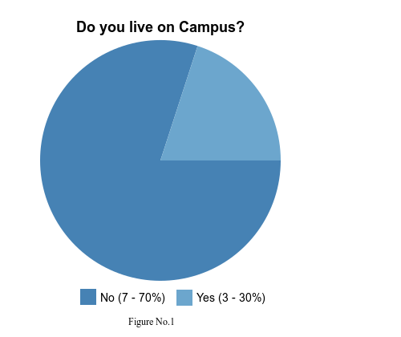

**Figure 1:** Distribution of respondents who do not live on campus.

In the case of the respondent’s average time spent on campus daily, 50% spend 2-4 hours, 30% 4-6 hours, and the rest spend 6+ hours as shown in Fig. 2.

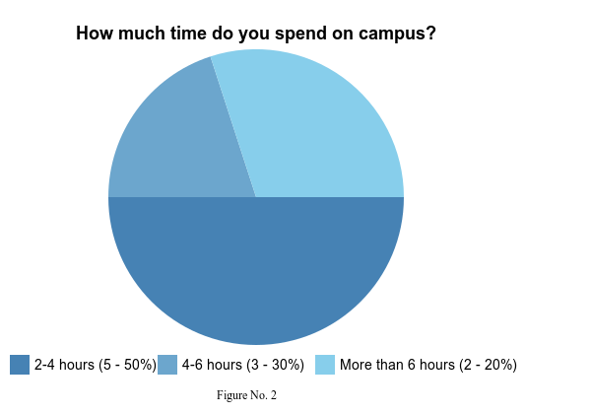

**Figure 2:** Distribution of respondent’s average time spent on campus.

Shown below in fig. 3, the majority of respondents always sort their trash, while 20% sometimes sort and the last 10% do not.

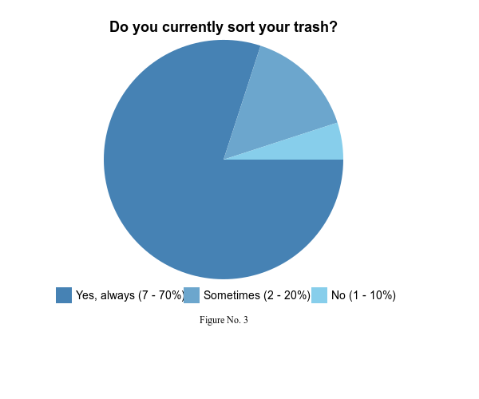

**Figure 3:** Distribution of Respondents who sort their trash.

Responses varied on difficulty when sorting personal trash, with 60% rating the difficulty a 3 out of 5 as shown below in fig. 4.

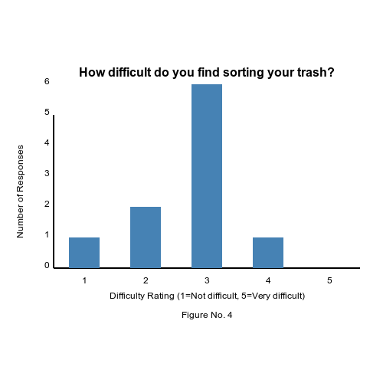

**Figure 4:** Respondent’s perceived level of difficulty in sorting trash rated out of five.

All respondents answered five out of five in how likely they would be properly sorting their trash with automatic sorting as shown below in fig. 5.

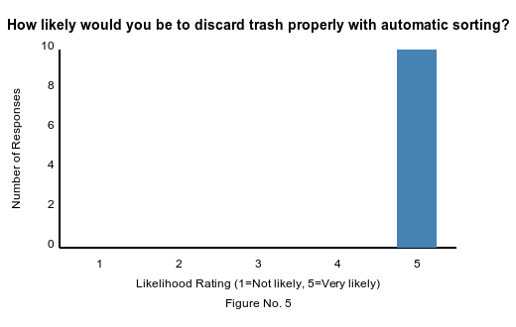

**Figure 5:** Distribution of Respondents on how likely they would properly sort their trash if automatic sorting is implemented rated out of five.

Majority of respondents choose yes while the last 20% choose maybe when asked if they would support the implementation of automatic trash sorting on campus, as shown in fig. 6.

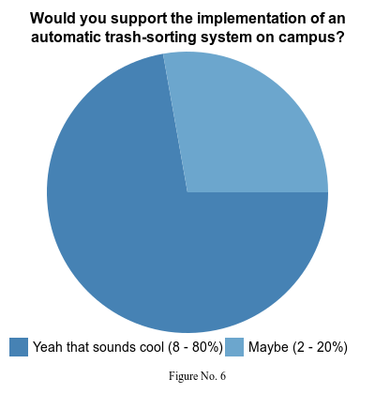

**Figure 6:** Respondents’ Support for Automatic Trash Sorting on Campus.

### Online Research Findings

Our secondary research focused on identifying technologies and cost estimations relevant to automated sorting solutions:

* AI Image Recognition and Thermal Imaging: Preliminary inquiries indicate that AI-driven image recognition, combined with thermal sensors, can potentially detect whether containers hold residual liquids or solid food. This approach is especially promising for high-volume sorting applications, where rapid and accurate classification is essential.
* Cost Considerations: Drawing on pricing data from suppliers such as Digi-Key Canada and other vendors, we compiled a rough breakdown of component costs for sensors, processing units, and peripheral hardware. Although further refinement is needed, these estimates help outline the budgetary implications of implementing an automated sorting system at scale. A Cost breakdown is available below in **Table 1: Cost Analysis.**
* Other Implementations and Case Studies: Existing case studies in large facilities demonstrated that AI-based sorting not only improves the accuracy of waste categorization but can also reduce labor-intensive manual sorting processes. These insights support the viability of a similar system on campus to mitigate common waste stream contamination.

Overall, the research suggests that applying AI technology to on-campus waste sorting could both streamline operations and address existing challenges, particularly handling partially filled containers and mixed materials.

**Note:** There are approximately 250 high volume Sort It Out stations on the UVic campus, out of a total of 527 Sort It Out stations.

**Table 1: Cost Analysis**

| **Part Name** | **Digikey ID** | **Unit Cost ($)** | **Units** | **Bulk Price Total ($)** |
| --- | --- | --- | --- | --- |
| **ESP32CAM** | 1188-ESP32-CAM-2MB-ND | 18.43 | 250 | 3,686 |
| **Motor** | 1568-ROB-20441-ND | 48.26 | 250 | 9,652 |
| **5V Wall Plug** | PSAW6I-10-B1 | 7.96 | 250 | 1,988.65 |
| **TOTAL** | | | | **15,326.65** |

### 

### Client Feedback

In our discussions with the client, several critical points were raised regarding both the scope and practicality of our proposed solution:

* Centralized Sorting System: The client recommended exploring the feasibility of installing one large-scale sorting system at the University of Victoria’s primary sorting facility, as opposed to multiple smaller units dispersed around campus.
* Targeting High-Volume Areas: Emphasis was placed on identifying buildings or zones generating the greatest volume of waste, such as popular dining halls or high-traffic student areas, before deploying any automated sorting technology.
* Detecting “Trash Within Trash”: A key concern involves containers that contain residual materials—whether food remnants, liquids, or other contaminants. The client suggested leveraging thermal imaging or similar sensor technologies to accurately gauge if a container is empty, reducing contamination in recycling and compost bins.
* Future Enhancements: Beyond the immediate technical capabilities, the client underscored the importance of scalability. Once a robust sorting system addresses the most prevalent mis-sorting challenges, it can be expanded to cater to less common but equally detrimental waste contaminants.

These insights affirm the need for a finely tuned and centralized approach to waste sorting that prioritizes large generators of mixed waste while incorporating advanced detection features to strengthen overall diversion efforts.

By integrating the survey findings, online research insights, and client feedback, our proposed strategy aims to reduce mis-sorting, enhance sustainability, and streamline waste management processes across campus.

## 

## Discussion

This section provides a detailed analysis of the findings from our research and survey data, highlighting key trends, patterns, and insights relevant to the feasibility of the project.

### Survey Results Discussion

We surveyed students to evaluate current waste management practices and the impact of an automated rubbish-sorting system. With 10 responses, the survey captured insights on disposal habits, sorting challenges, and interest in automation. As shown in Fig. 6, 80% of respondents support an automated system, while 20% are uncertain. Fig. 5 indicates that 100% would be “very likely” (5/5) to dispose of trash properly if such a system existed, underscoring its potential effectiveness. Currently, 70% always sort their trash, 20% do so occasionally, and 10% never sort (Fig. 3). Over half rated sorting as moderately difficult (3/5, Fig. 4), pointing to inefficiencies. These findings suggest automation could streamline waste disposal, making sorting easier and more consistent.

### Waste Generation and Sorting Challenges

Survey data also revealed key insights into waste production on campus. Although 70% of respondents live off-campus (see fig. 1), many spend extended periods on campus, with 50% reporting more than four hours per day on-site (see fig. 2). This suggests that waste generation is not exclusive to on-campus residents and that an automated sorting system would benefit a broad range of students.

Analyzing waste disposal trends, high waste producers include both on- and off-campus students. A single-bin automated sorting system could reduce mis-sorting and improve waste processing efficiency. If we assume a conservative mis-sorting rate of 5%, a significant amount of waste must be manually corrected. This not only increases labor demands but also complicates the recycling and composting process by introducing contamination.

### Feasibility and Implementation Considerations

The survey results strongly support implementing an automated sorting system. High approval rates and inefficiencies in manual sorting suggest it could improve waste management and free up manpower.

Despite the small sample size, the overwhelmingly positive response highlights demand for automation. Larger studies could further validate these findings, but current data suggests this system would enhance campus sustainability and efficiency.

With 80% in favor and 20% unsure (Fig. 6), support for automation is clear. Additionally, 100% of respondents (Fig. 5) stated they would properly dispose of trash if the system were available, reinforcing its potential effectiveness. While 70% already sort their waste regularly, 20% do so occasionally, and 10% never (Fig. 3), indicating room for improvement. Over half rated sorting as moderately difficult (3/5, Fig. 4), highlighting the need for a more efficient process.

Given that 70% of respondents live off campus but spend significant time there (50% over four hours daily, Fig. 1), implementing an automated system aligns with sustainability goals and user needs. The data strongly justifies moving forward with this initiative.

## Recommendation

Based on our research and analysis, we strongly recommend that the University of Victoria move forward with the development and deployment of the proposed AI-powered waste sorting system. The data indicate that integrating an ESP32-CAM module with a convolutional neural network (CNN) into the existing “Sort It Out” infrastructure can significantly improve waste sorting accuracy. This system is expected to reduce manual sorting efforts by up to 50% while increasing recycling rates, aligning with UVic’s sustainability targets and the goal of achieving an 81% landfill diversion rate. By effectively reducing contamination in recycling streams, lowering greenhouse gas emissions, and contributing to the long-term goal of minimizing reliance on Hartland Landfill, the proposed solution promises significant environmental benefits.

In addition to its environmental impact, the system offers substantial operational advantages. Automating the waste sorting process can lower labor costs by reducing the need for manual sorting, thus allowing staff to focus on other critical sustainability initiatives. This technological advancement also helps prevent future fees and penalties associated with landfill usage as regulations become more stringent and landfill space decreases. Furthermore, the improved user experience—through intuitive design and real-time feedback mechanisms—will educate and engage students and staff, reinforcing sustainable behaviors on campus.

To ensure a smooth transition, we propose launching a pilot program at high-traffic locations such as the student union building or library, with approximately 10 AI-enabled bins. During this phase, it will be essential to secure funding within the allocated budget of $100,000 and form partnerships with local government and community stakeholders. The pilot program will involve fine-tuning the CNN by training it with campus-specific waste images, evaluating its performance based on key metrics such as classification accuracy and user adoption, and gathering ongoing feedback through surveys and direct engagement with campus users.

Following the pilot phase, the system will be refined based on the insights gained, and a full-scale deployment across the campus will be initiated. This rollout will include comprehensive user education campaigns, clear signage, and incentives to promote correct usage. Periodic audits and data analyses will ensure the system's continued effectiveness and alignment with UVic's sustainability goals. By taking these steps, the University of Victoria can confidently implement an innovative, cost-effective, and environmentally responsible solution that enhances its waste management practices and reinforces its leadership in sustainable campus operations.

## 

## Conclusion

The study in this report verifies that improving waste management in this university is a necessity, particularly with its 81% diversion goal and the unsorted trash problem diverting manpower away from other tasks. From an online survey of AI sorting technologies to stakeholder consensus and campus survey [2], it was evident that installing an ESP32-CAM module with a convolutional neural network was technically viable as well as inexpensive. The survey feedback ascertained users’ adoption of an auto system, and cost calculation made certain that an AI-based system was firmly within the reach of this university's budget. Bringing these conclusions to their logical end, the single-point waste sorting design proposed would reduce labor, reduce contamination in recyclable streams, as well as enable the university to achieve its sustainability goals more effectively.

In short, the AI-based sorting system addresses not only the root cause of improper waste disposal, but also reaffirms the University of Victoria as one of the best in the world in promoting sustainable cities and communities. Running a pilot program in high-traffic areas and calibrating the tool based on campus-specific data, UVic can move ahead with full-scale deployment towards optimizing landfill diversion and operational effectiveness. Hence, we again recommend implementing its deployment. Early action will enable the university to enjoy longer-term environmental dividends associated with smarter waste management, neutralize financial risks associated with landfill usage, and spur higher responsible disposal behaviors among campus stakeholders.

## 

## References

[1] M. Yang, Y. Wang, and J. Zhang, "AI-based waste sorting: A review," *Waste Management Journal*, vol. 78, pp. 45-60, 2023. Accessed March 29th 2025

[2] A. Gupta and L. Brown, "Improving recycling through image recognition," *Journal of Environmental Engineering*, vol. 142, no. 3, pp. 112-125, 2022. Accessed March 29th 2025

[3] University of Victoria, "Waste management and campus initiatives," *Sustainability Report*, 2024. Accessed March 29th 2025

[4] “UVic a national leader in climate and sustainability,” *UVic News*, Jun. 12, 2024. [Online]. Available: <https://www.uvic.ca/news/topics/2024+the-global-impact-rankings+mediarelease#:~:text=UVic%20is%20ranked%20second%20in,and%20communities%20(SDG%2011)>. Accessed: Mar. 11, 2025.

[5] University of Victoria, *Waste to Resource Assessment™ Report*. [Online]. Available: <https://www.uvic.ca/facilities/assets/docs/UVic-waste-assessment-report.pdf>. Accessed: Mar. 11, 2025.

[6] University of Victoria, *Distinctly UVic: A strategy for the University of Victoria*. [Online]. Available: <https://www.uvic.ca/strategic-plan/_assets/docs/uvic-strategic-plan-2023.pdf>. Accessed: Mar. 11, 2025.

[7] J. MacLean, “Request for Proposals FM/WR 0520,” University of Victoria, Victoria, BC, Canada, 2024. Accessed: Mar. 11, 2025.

[8] University of Victoria, *Climate and Sustainability Action Plan 2030*. [Online]. Available: <https://www.uvic.ca/_assets/docs/csap2030-actions.pdf>. Accessed: Mar. 11, 2025.

[9] A Vallarta, A Shah, T Dargan, “Report 2: Pair Proposal - Team 6”, unpublished, Engineering 240, University of Victoria, Feb, 2025 Accessed: March 20th 2025.

[10] Digi-Key Electronics, "Digi-Key Canada," Digi-Key, [Online]. Available:<https://www.digikey.ca>. [Accessed: Apr. 2, 2025].

[11] University of Victoria, "Protection of Privacy Policy (GV0235)," University of Victoria, 2018. [Online].  
Available: <https://www.uvic.ca/universitysecretary/assets/docs/policies/GV0235.pdf>. [Accessed: Apr. 2, 2025].

## 

## Appendices

**Appendix 1. Work Log (Team)**

| **Team members**  **(Name)** | **Tasks** | **Total # of Hours** | **Signature of all team members** |
| --- | --- | --- | --- |
| Antonio | Initiation: Defined investigation scope, identified key research questions | 3 hr |  |
| Antonio | Document Design Template: Created template for report structure | 2 hr |  |
| Abdullah | Front Matter: Drafted title page, abstract, and table of contents | 3 hrs |  |
| Tanuj | Client Background: Compiled relevant background information | 3 hrs |  |
| Vidit | Developed charter: Defined objectives, stakeholders, and constraints | 3 hrs |  |
| Vidit | Planning and Design: Formulated research methodology, assigned responsibilities | 2.5 hrs |  |
| Antonio | Problem Definition: Outlined goals, problems, and research questions | 3 hrs |  |
| Tanuj | Technical Description: Documented technical details and requirements | 3 hrs |  |
| Antonio | Method of Assessment: Established criteria for evaluating research | 3 hrs |  |
| Vidit | Results: Compiled and structured collected data | 2.5 hrs |  |
| Abdullah | Execution: Conducted data collection, literature review, and analysis | 3 hrs |  |
| Abdullah | Discussion: Analyzed findings, identified trends, and key insights | 1 hrs |  |
| Abdullah | Recommendation: Suggested actionable steps based on research | 3 hrs |  |
| Tanuj | Conclusion: Summarized research and final thoughts | 2 hrs |  |
| Vidit | References: Cited all sources used in research | 1 hrs |  |
| Tanuj | Evaluation: Assessed completeness and validity of findings | 3 hrs |  |
| Abdullah | Appendices: Compiled supplementary materials | 1 hrs |  |
| Full Team | Revising and Editing: Reviewed and refined document content | 6 hrs |  |
| Tanuj | Final Proofread: Checked for grammar, clarity, and coherence | 1 hrs |  |
| **TOTAL** |  | 49 hrs |  |

**Appendix 2. Individual Work Log - Antonio Vallarta**

| **Name** | Antonio Vallarta | **Project**:  Report 3: Feasibility Report |
| --- | --- | --- |
| **Signature** | Antonio |
| **Work Log** | | |
| | **Date** | **Work completed** | **Time spent** | **Total hrs** | | --- | --- | --- | --- | | 2025-03-16 | Initial Document layout | 2 hrs | 2 hrs | | 2025-03-20 | Wrote Problem Def | 3 hrs | 5 hrs | | 2025-03-29 | Formatting | 1 hrs | 6 hrs | | 2025-03-30 | Proofread and wrote Methodology | 5 Hours | 11 Hours | | 2025-04-01 | Proofread & Revisions | 1 hours | 12 hours | | 2025-04-03 | Final Proofread and Final edits | 6 hours | 18 hours | |  |  | TOTAL HRS | 18 Hours | | | |

**Appendix 3. Individual Work Log - Abdullah Shah**

| **Name** | Abdullah Shah | **Project**: Report 3 – Team 8 |
| --- | --- | --- |
| **Signature** | Shah |
| **Work Log** | | |
| | **Date** | **Work completed** | **Time spent** | **Total hrs** | | --- | --- | --- | --- | | 3/12/25 | Drafted the Front Matter section | 1.0 hour | 1.0 hour | | 3/13/25 | Revised Front Matter; integrated team feedback | 2.0 hours | 3.0 hours | | 3/18/25 | Conducted data collection, literature review, and analysis | 3.0 hours | 6.0 hours | | 3/22/25 | Analyzed findings, identified trends, and key insights | 1.0 hours | 7.0 hours | | 3/29/25 | Drafted the Recommendation section | 2.0 hour | 9.0 hours | | 4/1/25 | Revised the Recommendation section | 1 hour | 10.0 hours | | 4/2/25 | Appendices | 1 hour | 11.0 hours | | 4/3/25 | Conducted the Organizational Review portion of the report | 1.5 hour | 12.5 hours | | 4/3/25 | Final check on Organizational Review; minor edits | 1.5 hour | 14.0 hours | |  |  | TOTAL HRS | 14.0 hours | | | |

**Appendix 4. Individual Work Log - Tanuj Dargan**

| **Name** | Tanuj Dargan | **Project**: Report 3 Team 8 |
| --- | --- | --- |
| **Signature** | Tanuj D. |
| **Work Log** | | |
| | **Date** | **Work completed** | **Time spent** | **Total hrs** | | --- | --- | --- | --- | | 03/13/2025 | Client Background Research and collecting information | 1 hour | 1 hours | | 03/14/2025 | Client Background: Compiled relevant background information | 2 hours | 3 hours | | 03/18/2025 | Technical Description: Documented technical details and requirements | 3 hours | 6 hours | | 03/25/2025 | Conclusion: Summarized research and final thoughts | 2 hours | 8 hours | | 03/26/2025 | Evaluation: Assessed completeness and validity of findings | 3 hours | 11 hours | | 04/03/2025 | Revising and Editing: Reviewed and refined document content | 5 hours | 16 hours | | 04/03/2025 | Final Proofread: Checked for grammar, clarity, and coherence | 1 hours | 17 hours | |  |  | TOTAL HRS | 17 hours | | | |

# 

**Appendix 5. Individual Work Log - Vidit Mehta**

| **Name** | Vidit Mehta | **Project**: Report 3 – Team 8 |
| --- | --- | --- |
| **Signature** | V. Mehta |
| **Work Log** | | |
| Enter the date, describe the *specific* work you did on the team report (do not include the Progress Report), and record the time you spent on each task. E.g. *Nov 20. Created the online survey. 2 hrs; Nov 27. Wrote the Discussion section. 2.5 hrs; Nov 29. Proofread and did final edits. 2.5 hrs.*   | **Date** | **Work completed** | **Time spent** | **Total hrs** | | --- | --- | --- | --- | | 03/13/2025 | Developed charter: Defined objectives, stakeholders, and constraints | 3 hours | 3 hours | | 03/16/2025 | Planning and Design: Formulated research methodology, assigned responsibilities | 2.5 hours | 5.5 hours | | 03/26/2025 | Results: Compiled and structured collected data | 2.5 hours | 8 hours | | 03/29/2025 | References: Cited all sources used in research | 1 hour | 9 hours | | 04/03/2025 | Revising and Editing: Reviewed and refined document content | 6 hours | 15 hours | |  |  | TOTAL HRS | 15 hours | | | |

**Appendix 6. Meeting 1 - Recorder’s Document**

**Recorder’s Document**

**Meeting date: 2025-02-27 Recorder: Antonio Vallarta**

**Group members present: Abdullah, Antonio, Tanuj, Vidit**

**Roles assigned: Time-Keeper, Team Leader, Process Facilitator**

**Agenda item 1:**

**Choose Roles**

**Discussion:**

Looked and talked about the different roles and responsibilities and each member picked a role.

**Decision:**

Antonio as Recorder, Abdullah as Time-Keeper, Tanuj as Leader, and Vidit as Process Facilitator and that for the next meeting the recorder will switch roles with the next recorder.

**Action (who/when/what):**

Abdullah took Time-Keeper, Antonio took Recorder for session 1, Tanuj and Vidit were up for any role so we decided to give Tanuj Leader and Vidit as Facilitator.

**Agenda item 2:**

**Decide Time and Location of Meetings**

**Discussion**

Discussed possible times, locations, and communication platforms.

**Decision:**

Meetings will take place in the Library at Friday 3pm, and alternatively on Discord when needed. Main communication platform is decided as Discord.

**Action (who/when/what):**

Tanuj brought up the Library on Fridays at 3pm as an option and we all agreed, Antonio said to write down the communication platform to be Discord as that’s what was already being used.

**Agenda item 3:**

**Share By-laws to possibly add to Charter**

**Discussion**

Shared possible By-laws and decided on 4 to add to charter.

**Decision:**

Decided on the four bylaws to be Constructive Communication, Punctuality and Preparedness, Promote Diverse Collaboration, and Handling Absenteeism.

**Action (who/when/what):**

All members shared 2 bylaws from “Introduction to teamwork” or from their brain and took 4 of them to add to the charter.

**Date for next meeting:**

**Library, March 7th 3pm**

**Appendix 7. Meeting 2 - Recorder’s Document**

**Recorder’s Document**

**Meeting date: 2025-03-07 Recorder: Tanuj Dargan**

**Group members present: Abdullah, Antonio, Tanuj, Vidit**

**Roles assigned: Timekeeper, Team Leader, Process Facilitator, Task Delegator**

**Agenda item 1: Review of Milestone 2 Requirements**

**Discussion:**

* The team reviewed the instructions for Milestone 2, which include creating a detailed work schedule (with tasks, responsible team members, and deadlines), as well as completing the Team Skills Exercise and compiling a Master List of Team Skills.
* Also discussed the need to ensure the deliverables are in a clear, accessible format (e.g., Gantt chart or table).

**Decision:**

* The team will produce both a Gantt chart and a task list/table to address all Milestone 2 requirements.
* We will also finalize the Master List of Team Skills in a shared document and email it to the instructor.

**Action (who/when/what):**

* Vidit will review the already drafted Gantt/table by today.
* Antonio will create the draft and incorporate feedback from Vidit and finalize the chart by today.
* Tanuj will organize the Master List of Team Skills in a single document and circulate it to the team for approval before sending it.

**Agenda item 2: Task Breakdown and Gantt Chart**

**Discussion**

* Each section of Report 3 was discussed: Front Matter, Body (Client Background, Problem Definition, Technical Description, Method of Assessment, Results, Discussion, Recommendation, Conclusion), Back Matter, and final editing steps.
* The corresponding timeline was cross-checked with class deadlines.

**Decision:**

* The current breakdown is acceptable but needs minor adjustments to align sub-deadlines with each member’s availability.

**Action (who/when/what):**

* Abdullah and Antonio will meet online (Discord) on 2025-03-09 to finalize adjustments to the Gantt chart dates.
* Tanuj and Vidit will proofread the revised chart by 2025-03-09 to confirm the alignment of tasks and deadlines.

**Agenda item 3:** **Finalize Team Skills Document**

**Discussion**

* Each member has selected one skill from Category 1, 2, and 3 (Research/Drafting/Revising; Document Design/Graphics/Presentation; and Teamwork/Leadership).
* Confirmed that the final compiled list accurately reflects each person’s chosen skill sets and learning goals.

**Decision:**

* The group agreed that the compiled skills list is accurate.
* We will label it “Master List of Team Skills (Team #)” and attach it in a professional email to the instructor.

**Action (who/when/what):**

* Tanuj & Antonio to finalize the document by 2025-03-09.
* Antonio to send the professional email to the instructor with the attached Master List by 2025-03-09.

**Agenda item 3:** **Next Meeting Logistics**

**Discussion**

* Confirmed in-person meeting preferences vs. online check-ins.
* We want to keep the same location and time arrangement when possible.

**Decision:**

* Next meeting will be in the library on 2025-03-11 at 3 PM, with an alternative Discord check-in if needed.

**Action (who/when/what):**

* Abdullah (Time-Keeper) will send a reminder on the team’s Discord channel at least 24 hours before the next meeting.
* All team members will review the updated Gantt chart and tasks beforehand.

**Date for the next meeting:**

**Library, March 11th 3pm**

**Appendix 8. Meeting 3 - Recorder’s Document**

**Recorder’s Document**

**Meeting date: March 11th, 2025 Recorder: Vidit Mehta**

**Group members present: Abdullah, Tanuj, Vidit, Antonio**

**Roles assigned:** Tanuj **(Process Facilitator),** Vidit **(Recorder),** Abdullah **(Timekeeper),** Antonio **(Leader)**

**Agenda item 1: Review of Milestone 3 Requirements**

**Discussion:**

* The team reviewed the Milestone 3 document, including the client background, problem definition, plan of action, budget, and results.
* The focus was on ensuring that each section is comprehensive and aligns with project goals.

**Decision:**

* Each section will be reviewed individually and edited for clarity and completeness.

**Action (who/when/what):**

* Abdullah will verify the problem definition by 2025-03-14.
* Antonio will finalize the budget section by 2025-03-15.
* Tanuj and Vidit will proofread the entire document by 2025-03-15.

**Agenda item 2: Technical and Management Plan Updates**

**Discussion**

* The team assessed the technical and management plans, confirming that the methods and strategies proposed are feasible given the resources available.

**Decision:**

* Minor changes will be made to ensure the plan aligns with university policies.

**Action (who/when/what):**

* Antonio to check the feasibility of the management plan by 2025-03-16.
* Tanuj to refine the technical plan and ensure accuracy by 2025-03-16.

**Date for next meeting:**

**March 16th, 2025**

**Appendix 9. Meeting 4 - Recorder’s Document**

**Recorder’s Document**

**Meeting date: March 16, 2025 Recorder: Abdullah Shah**

**Group members present: Tanuj, Antonio, Abdullah, Vidit**

**Roles assigned:** Tanuj **(Team Leader),** Antonio (**Timekeeper),** Vidit (**Process Facilitator),** Abdullah (**Task delegator and recorder)**

**Agenda item 1: Slide Design Decisions**

**Discussion:**

* The team reviewed the requirements for creating a slide design template for the Progress Report (Milestone 4).
* Tanuj suggested using a clean, minimalist layout with a consistent color palette and a clear, legible font.
* Antonio recommended using placeholders for images, tables, and figures so that the final presentation can be easily updated with visuals.
* Vidit noted the importance of including consistent slide headers and footers to maintain a professional look.

**Decision:**

* Adopt a minimalist template with consistent branding across all slides.
* Ensure each slide has a header and/or footer for team name, slide number, and date.

**Action (who/when/what):**

* Tanuj will create a draft PowerPoint/Google Slides template (color scheme, font) by March 16.
* Antonio will quickly review font readability on multiple devices and provide feedback by March 16.
* Viditwill insert placeholders for images, charts, and tables into the final template by March 16.

**Date for next meeting:**

March 17, 2025 (to review and approve final slide template).

**Agenda item 2: Slide Headings & Descriptors**

**Discussion**

* The group confirmed the slide headings required for the Progress Report: Title Slide, Overview, Client Context, Problem Definition, Timeline, Work Completed, Challenges, Work Remaining, Expected Outcomes, References, and Q&A/Feedback.
* Each slide needs 1–2 descriptive sentences outlining its purpose.
* Abdullah reminded everyone to include placeholders for visuals, especially for the Work Completed and Findings slides.

**Decision:**

* Finalize the slide headings and short descriptions on each slide.
* Incorporate placeholders where needed (charts, images, tables).

**Action (who/when/what):**

* Abdullah will draft 1–2 sentence descriptors for each slide and share with the team by March 17.
* Vidit will integrate these descriptors into the slide template before submission.

**Date for next meeting:**

March 18, 2025 (combined with the template review)

**Agenda item 3:**  **Ongoing Discussion & Finalizing Next Steps**

**Discussion**

* The team is actively discussing additional improvements to the slide outline and overall presentation before the final submission.
* Ideas include refining slide descriptors, adjusting visual placeholders, and ensuring that the narrative clearly aligns with the project’s objectives.
* The discussion is open, and decisions will be made once all team members have contributed their final thoughts.

**Decision:**

We agreed to submit the slide template since everyone was satisfied with it

**Action (who/when/what):**

* Tanuj will performone last review of the template to confirm that each slide’s content and design align with the project objectives.
* Antonio  will double-check that the final slide deck remains within the allotted presentation time, noting any slides that may need trimming or additional detail.
* Vidit will ensure all visual placeholders (images, charts, tables) are correctly positioned and labeled so the team can easily add content later.
* Abdullah will finalize any minor edits identified during the review and submit the completed slide template by the agreed deadline.

**Date for next meeting:**

A follow-up discussion may be scheduled on March 19, 2025, if further clarifications are required after final review.

**Appendix 10. Meeting 5 - Recorder’s Document**

**Recorder’s Document**

**Meeting date: March 29, 2025 Recorder: Tanuj Dargan**

**Group members present: Tanuj, Vidit, Abdullah, Antonio**

**Roles assigned:** Tanuj **(Task delegator),** Abdullah **(Process Facilitator),** Antonio **(Team leader),** Vidit **(Timekeeper)**

**Agenda item 1: Rectifying mistakes for the Feasibility report slides**

**Discussion:**

* We used the slides templates which we uploaded for milestone 3. Again, there were a lot of errors and mistakes which we realized following up on the feedback we received.
* We discussed who did what when we created the slides template so that we can ask them how and why they got the things wrong.
* We also argued that how did we miss the exclusive summary page which was supposed to be there but for some reason we forgot to add it.
* All the team members misinterpreted the goal of the assignment due to which we added footnotes as well which was not even required, and we just got the entire template wrong, so we just asked each other why and how we got the entire assignment wrong.

**Decision:**

* Remove unnecessary footnotes, incorporate the summary page, and correct all design and textual errors.
* Rely on the updated feedback from Milestone 3 to ensure full compliance with assignment guidelines.

**Action (who/when/what):**

* Tanuj will revise the existing slides and remove all outdated elements by March 31.
* Abdullah will cross-check the updated slides against the Milestone 3 feedback and assignment instructions by March 31.

**Date for next meeting:**

**March 31, 2025**

**Agenda item 2: Starting from scratch by creating the slides**

**Discussion**

* We discussed maybe making the entire slides again since we got the entire assignment wrong.
* Tanuj emphasized to keep the checklist on the side to get an idea of how and in what order is the report needed to be
* We decided to assign the first 4 sections to Tanuj and Vidit and the remaining 4 sections to be distributed among Abdullah and Antonio.
* Also, we discussed adding figures table as well since we missed that as well when we submitted the slide template before.

**Decision:**

* Rebuild the slide deck from scratch, referencing the assignment checklist at every stage.
* Assign Sections 1–4 to Tanuj and Vidit, and Sections 5–8 to Abdullah and Antonio.

**Action (who/when/what):**

* Tanuj & Vidit will create slides for Sections 1–4 by April 2.
* Abdullah & Anotnio will develop slides for Sections 5–8 by April 2.
* All Members will coordinate to ensure the figures table is accurately populated and the overall format is consistent.

**Date for next meeting:**

**April 2, 2025**

**Agenda item 3: Checking what we have done so far**

**Discussion**

* We discussed what we have done so far
* Tanuj was still working on a proposed design solution. We discussed if we needed to maybe add more context in it and check whatever he has mentioned is correct or not
* Vidit asked about how to create figures, pie-charts and all to support our findings so we discussed and guided him on how to do that.
* Antonio still had to work on the discussion part
* Abdullah was done with recommendation part and wanted some points on how the conclusion part was to be written so we spent some time explaining how it is to be done

**Decision:**

* Tanuj will finalize the proposed design solution with any missing details or corrections.
* Vidit will create clear figures and pie charts, ensuring they align with the data and enhance readability.
* Antonio will complete the discussion section, integrating the feedback provided by the team.
* Abdullah will refine the recommendation and conclusion sections based on the agreed outline and style.

**Action (who/when/what):**

* Tanuj will incorporate all necessary updates into the design solution by April 2.
* Vidit will finalize the figures and pie charts, verifying data accuracy by April 2.
* Antonio will finish writing the discussion section and review it with the team by April 3.
* Abdullah will revise and finalize the recommendation and conclusion sections by April 3.

**Date for next meeting:**

**April 3, 2025**

**Appendix 11. Meeting 6 - Recorder’s Document**

**Recorder’s Document**

**Meeting date: April 3, 2025 Recorder: Antonio Vallarta**

**Group members present: Abdullah, Tanuj, Vidit, Antonio**

**Roles assigned:** Tanuj **(Process Facilitator),** Vidit **(Team leader),** Abdullah **(Timekeeper),** Antonio **(recorder)**

**Agenda item 1: Finalizing the Feasibility report**

**Discussion:**

* We discussed if we all were done with whatever slides we were assigned with.
* We asked Vidit if he was able to generate the graphs and all and ask if he was done with all the work
* We discussed before submitting the report, Abdullah should just once more go through all the report and even simultaneously keep the checklist on the side to see if all the requirements are completed
* Antonio was a bit confused with back matter last meeting, so we checked with him if that issue was clear and resolved.

**Decision:**

* Conclude that all sections of the feasibility report are finished and ready for a final review.
* Abdullah will do a thorough checklist-based review to confirm that every requirement is satisfied.

**Action (who/when/what):**

* Abdullah will conduct a final read-through, cross-referencing the assignment checklist, and make any last-minute corrections or adjustments by today.
* Antonio and Tanuj will stand by to assist with any minor edits as needed.

**Date for next meeting:**

**We finished our project**